**CANADA FRESH WP ICT – DOCUMENT CHECKLIST & INSTRUCTION**

* **All documents should be legible and good quality.**
* **All documents should be in English, if having any other regional languages, need to provide translated version.**
* **All documents should be in PDF format, except, photograph, PRD, & Resume.**
* **Onsite Role, Location should be match in GMS request, PRD, WP application form and Resume.**

**PASSPORT:**

* Passport should be legible, hand written will not be acceptable. All the pages should visible edges.
* Passport should have a validity of minimum 12 months.
* If associate already travelled any other country, he must provide the visa and entry date stamp pages. Required all the nonblank passport pages for visa processing.

**PRD:**

* Type of application – Should be Fresh ICT Application, Company, designation, Grade, WON/SWON, RGS ID, Base branch should be matching with GMS request.

|  |  |
| --- | --- |
| **Project Role Description - The contents in this PRD need to be vetted & approved by Project Manager/BRM** | |
| **Type of Application Proposed** |  |
| **Company** |  |
| **TCS Designation & Grade** |  |
| **WON/SWON No.** |  |
| **RGS ID** |  |
| **Base Branch** |  |

* Biographical Data should be matching with GMS and associate passport.

|  |  |  |  |  |
| --- | --- | --- | --- | --- |
| **Biographical Data** | | | | |
| **Details required** | **Principal Applicant** | **Spouse (if applicable)** | **Child 1 (if applicable)** | **Child 2 (if applicable)** |
| **TCS Employee #** |  |  |  |  |
| **TCS Joining Date** |  |  |  |  |
| **BA Joining Date (if working for BA, prior to joining TCS)** |  |  |  |  |
| **First Name (Given Name)** |  |  |  |  |
| **Last Name (Surname)** |  |  |  |  |
| **Have you ever used any other names?** |  |  |  |  |
| **If yes to the above question, what is the type of Name** |  |  |  |  |
| **First Name (Given Name)** |  |  |  |  |
| **Last Name (Surname)** |  |  |  |  |
| **Citizenship** |  |  |  |  |
| **Place of Birth** |  |  |  |  |
| **If you are legally allowed to live in any country other than your country of birth, list each country and state your status in that country (e.g. US citizen, Canadian PR)** |  |  |  |  |
| **Do you have any other valid passport? If "yes", provide details on a separate sheet** |  |  |  |  |
| **Gender** |  |  |  |  |
| **Date of birth** |  |  |  |  |
| **Marital status** |  |  | N/A | N/A |

* If applying along with dependents, the below question should be yes and associate needs to update their dependents details in PRD.

|  |  |  |  |  |
| --- | --- | --- | --- | --- |
| **Dependents - Will accompany principal applicant to Canada?** |  |  |  |  |

* Should have mention both Permanent and Current residential address. At least current residential address should be match with IMM 1295 Wp Application form.

|  |  |  |
| --- | --- | --- |
| **Permanent address in home country** |  |  |
| **Current residential address** |  |  |

* If associate applying from USA, they were exempt from completing medicals, associate should update whether they have completed medicals or not, if not need to provide the reason.

|  |  |  |  |
| --- | --- | --- | --- |
| **Have you had an Immigration Medical Examination?** |  |  |  |
| **If no for above question, please provide reasons** |  |  |  |

* The below fields must filled by associate, the work location address details should be match in PRD, WP application form and GMS system. If there is any difference, need to check with associate. The complete address along with post code is required.

|  |  |
| --- | --- |
| **Information about the Assignment in Canada** | |
| **Name and full address of TCS client in Canada** |  |
| **Work Location address (if different from above)** |  |

* The Onsite role should be match in PRD, Resume, WP Application form and GMS system & iEvolve Screen shot. The role tagged in iEvolve, associate should connect with their respective project team and UNIT HR to change the role correctly in iEvovle role.

|  |  |
| --- | --- |
| **Employee’s actual role at client location** |  |
| **Employee’s current role in iEvolve** |  |

* Should Update 4 to 5 TCS tools which is using in project in under List of the TCSL tools required to carry out this work (IF APPLICABLE TO THE PROJECT) field. Update usage and responsibilities of those tools in detail manner. If not using, associate should update as **NOT USING IN MY PROJECT.**

|  |  |
| --- | --- |
| **List of the TCSL tools required to carry out this work (IF APPLICABLE TO THE PROJECT)** |  |

* Explain in detail – from row 67 to 85 in detailed description we required. Based on the details mentioned in your PRD, our attorneys will prepare the draft letter. Hence request you to provide the descriptions in detail manner.

**BRM APPROVAL TEMPLATE:**

* Fill up the BRM approval template in Guidelines and arrange your BRM confirmation and upload the approval mail along with BRM Approval template.



**iEvolve role Screen shot:**

* Should provide us iEvolve role tagged snap shot or ultimatix home page showing associate role snap shot.
* If someone applying from USA, ask them to ensure to change iEvolve role before travelling to Canada.

**ERL:**

* If someone applying from other countries (Other than India) they should connect with their respective country HR team to arrange Employer reference letter with respective country letter head and respective country HR should sign it.



**RESUME:**

* Minimum of 7-10 responsibilities for each projects.
* TCS tools provided in PRD should be explained in responsibilities section of TCS projects by showing 1 year of exp. Work location(Onsite/Offshore) should be updated correctly for all the projects, Should mention only project roles and not designation.
* The project details should be provided in continuously, if any gaps between two projects, need to update the reason for gap.
* The onsite and offshore work location or duration should be showed separately.
* If associate having any previous experience, they must update those details in Resume.

**IMM 1295 (WP APPLICTION FORM) – Current Version – 06 2019 (APPLICABLE FOR PRIMARY APPLICANT):**

* WP application must be in editable format, should not be validated. Version should be current 06 2019.

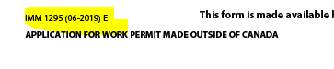

* Name should be as per passport, if surname not available in passport. Must update full name field with given name details, and given name field should be blank.

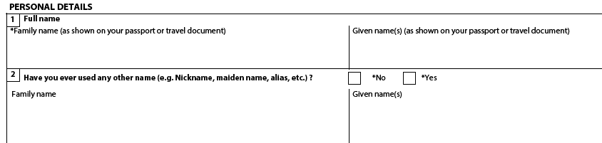

* Biographical details should be match with passport copy.

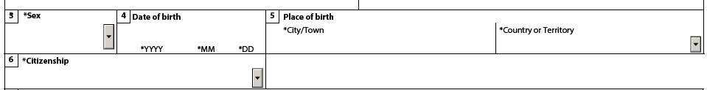

* Current country or Territory of residence – If associate deputed to any other countries, they should update deputed country details with start date and end date of visa or RP or WP or Petition details.
* If associate applying and residing in India, they should select status as Citizen.

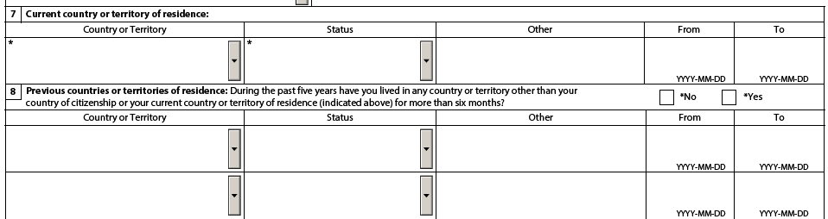

* Marital status and details of spouse should be checked with marriage certificate.

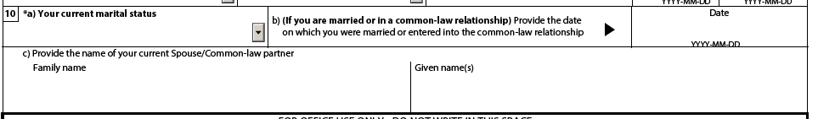

* If someone divorced, they have to update those details in the below field.

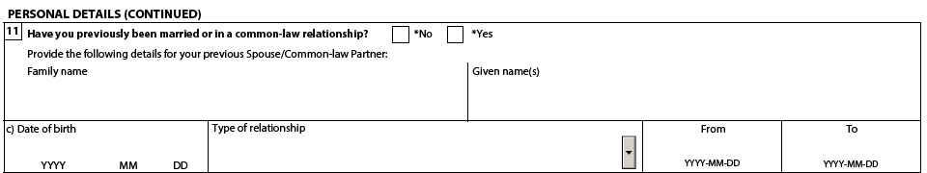

* Should update Native Language or Mother tongue and should update Are you able to communicate in English and/Or French.
* Also, if holding any English proficiency certificate, they must select yes for below question and provide us the proof of the same.

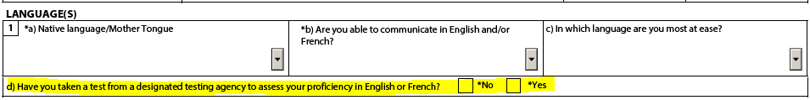

* Passport details should be cross verified with passport copy.

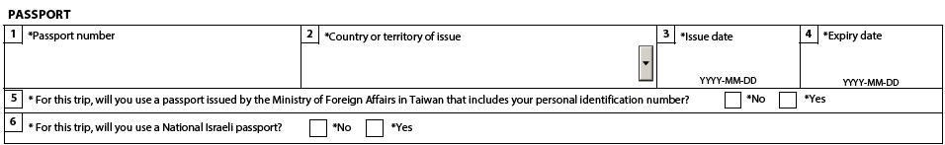

* If someone selected yes for National Identity document, they should be update the details and provide the proof of the same. Passport details should not be mentioned as National Identity document.

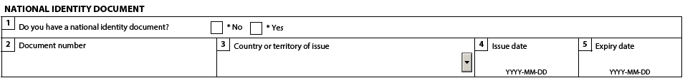

* Current mailing address should be always blank, address details should be updated in Residential address field only.

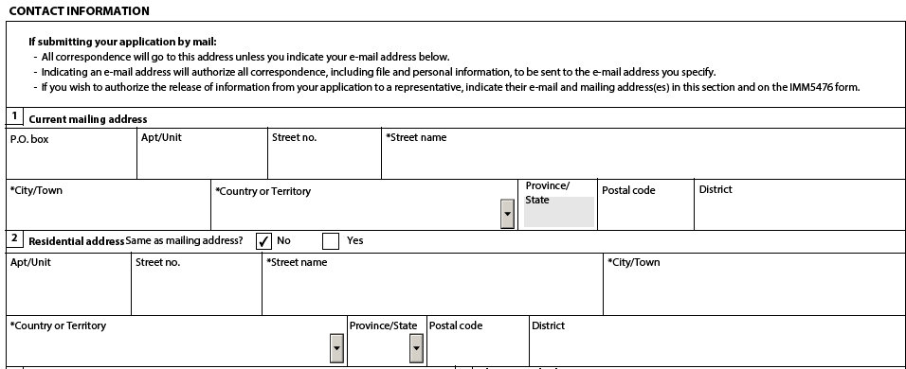

* Should update Telephone no alone in WP application form, Alternate telephone number, Fax no and Email address should be updated by our attorneys. If associate updated their details, you can ask them to keep it as blank.

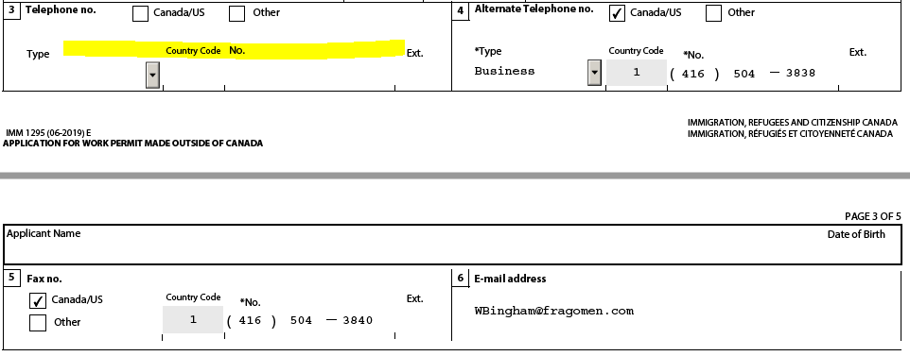

* The type of work permit are applying is **EXEMPTION FROM LABOUR MARKET IMPACT ASSESSMENT** only.

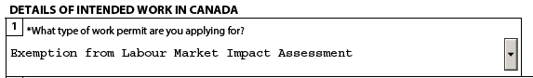

* Details of my prospective employer should no be change, as per the below it should be match in WP application form.

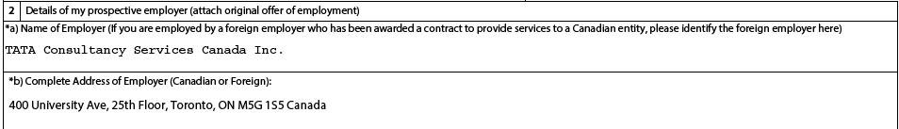

* Should be updated exact work location address details with postal code. Should match with GMS system and PRD.

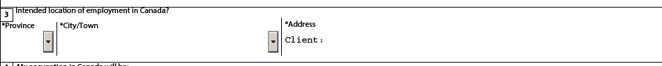

* Onsite role should be updated under Job title, should be match with GMS system, iEvolve and PRD, Resume.
* Duration of expected employment should be provided for 24 months maximum. LMIA number should be blank.

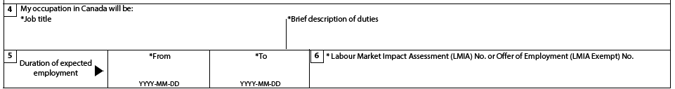

* Highest Degree details should be updated and cross verified with Degree certificates.

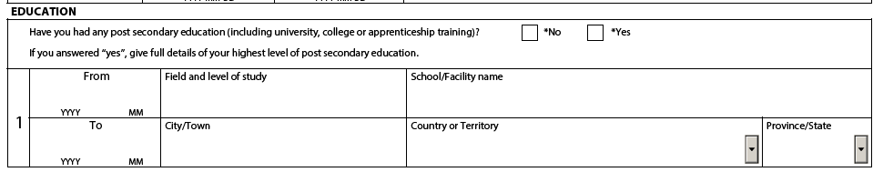

* Employment history should be provided for last 10 years (All the activities – employment, unemployment, education) of all the activities should be captured without any gaps. Onsite and offshore details should be separately provided and if associate performing different roles, separately update those duration.

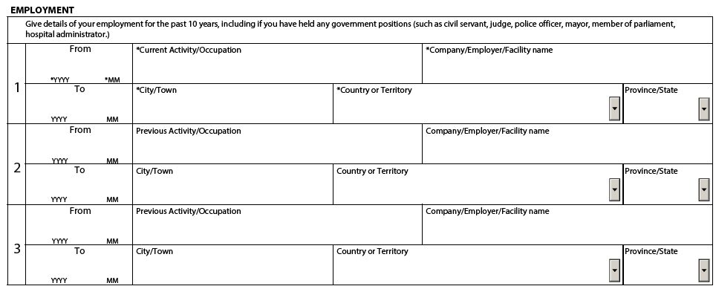

* Most recent 3 entries should be updated in WP application form. Remaining of details should be updated in additional employment sheet.



* In the Background information field should be updated by associate, if earlier visa refused means, need to update those details and share us the proof of refusal letter. If someone already travelled to Canada or applied, they should update those details in 2 D section.

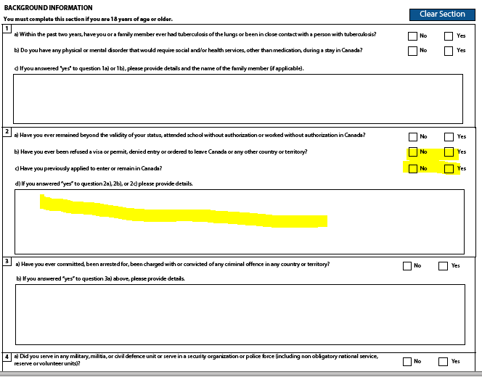

* Should not be sign and do not validate the form, please select the concern of contacting in future by IRCC should be answered.

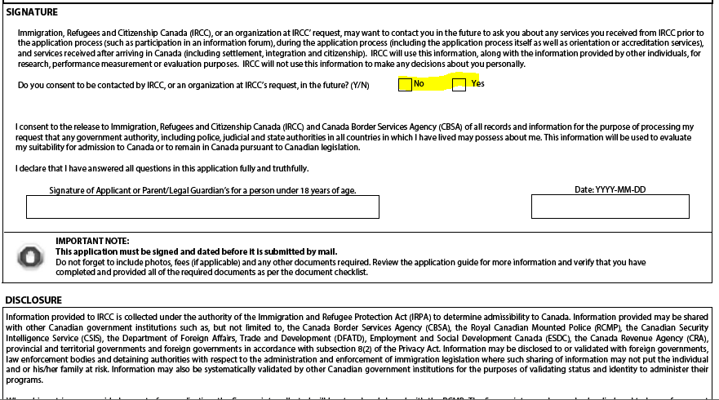

**IMM 5476 (USE OF REP FORM)- CURRENT VERSION (07 2021): (APPLICABLE FOR EVERYONE – ASSOCIATE, SPOUSE, KIDS)**



* Should be select Appointing a Representative.

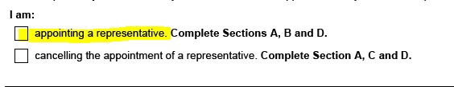

* Update name and date of birth as per passport.

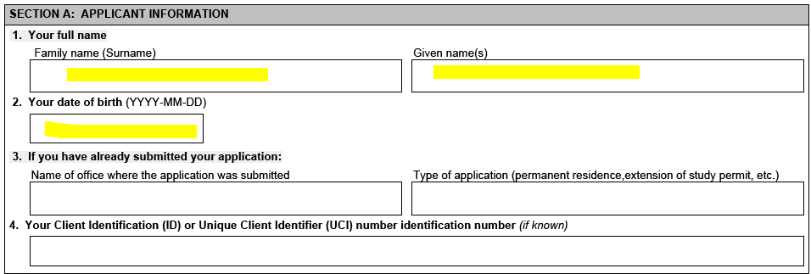

* No need to update Representative details
* Should be recently signed and dated. If associate single & applying alone (If married) they should alone sign the form.
* If associate applying along with spouse, he must sign and include her wife signature as spouse.

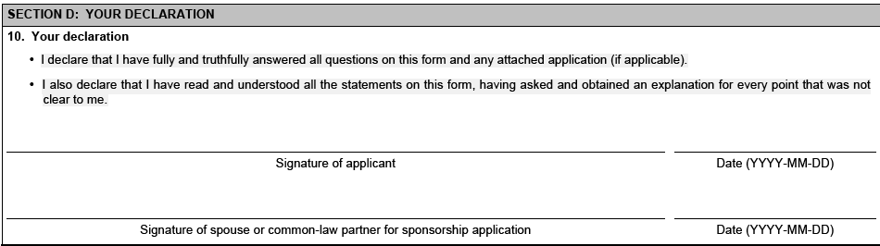

* In the same manner, separate form is required for spouse and kids.
* In the spouse representative form, spouse details have to be updated, spouse (Dependent) signed as a primary applicant and TCS associate should be signed as an spouse.
* In the kid’s representative form, Kids passport and date of birth should be updated, TCS associate alone should sign it as Guardian.
* Should be signed and good quality of scanned PDF copy required.

**IMM 5645 (Family Information form) – Current version 01 2021 (APPLICABLE FOR ASSOCIATE AND WIFE – NOT REQUIRED FOR KIDS):**



* The type of application should be worker for primary applicant, in the spouse family information form should be selected as Visitor as Type of application.

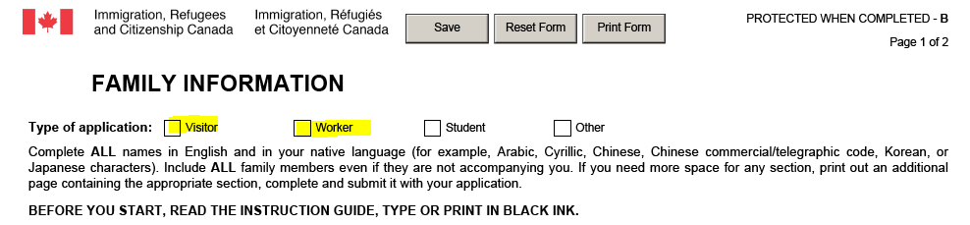

* In section A, should update, primary applicant and his spouse, primary applicant father and mother details. All the fields should be updated, should not kept it as blank.
* In the spouse Family information form, spouse details should be updated as primary applicant and father and mother details of spouse should be updated.

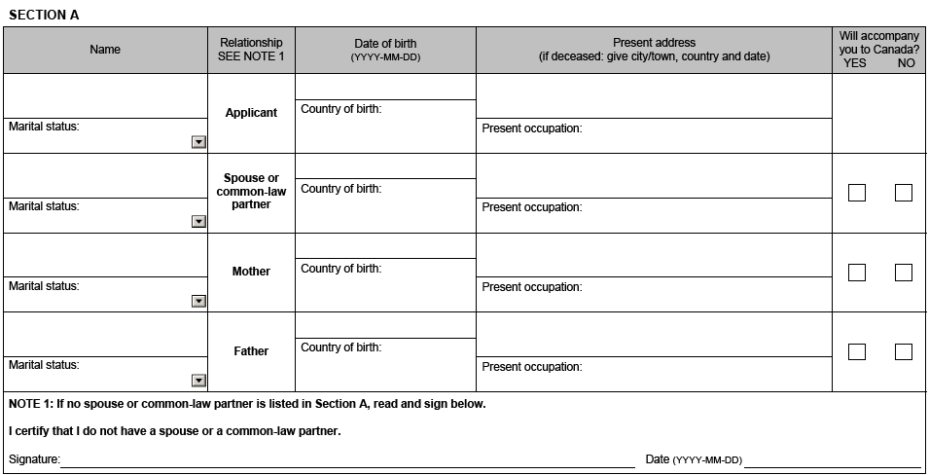

* The associate and family members names should be both in English and Native language. (Should type their names in English and take the print out and mention their names in Native language/mother tongue)

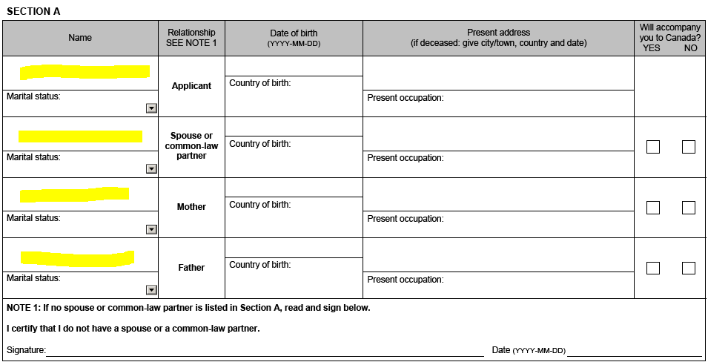

* If associate single not married, they should sign section A.
* Section B is applicable for update kids details and If anybody doesn’t have kids, they should sign the section B. If dependents are accompanying with applicant, should be selected as Yes.

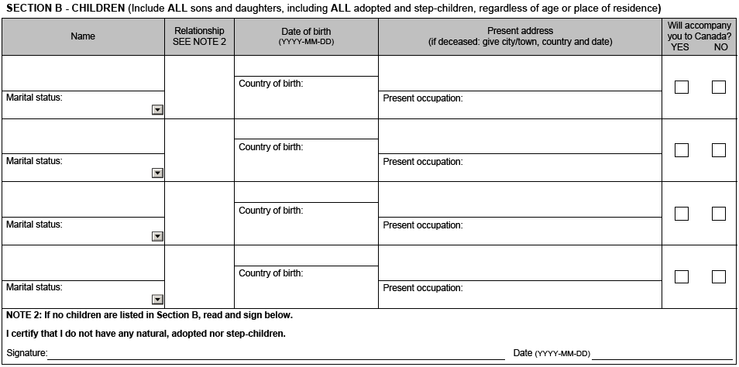

* Section C is applicable for brothers and sisters’ details. Should be filled all the required details.
* Section D should be recently signed and dated. Should be signed and scanned copy require for processing.

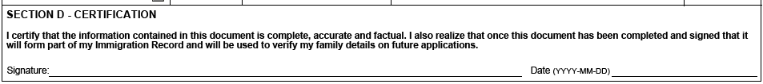

**FRAGOMEN ACKNOWLEDGEMENT FORM: (Applicable for Primary applicant alone)**

* Should be shared as signed and scanned copy required. The date should be recent within one month from the signed.

**MEDICALS:**

* Immigration medical acknowledgement copy is required. Medical should be applicable for everyone, who applying Canada visa.

**Degree:**

* Degree convocation certificate is required, need to cross verified with Resume and WP application form.
* If holding UG and PG, should be provided for both degree convocations.

**Mark sheets:**

* Consolidated or all semester marksheets should be provided.

**PAYSLIPS:**

* Requires last 3 months of payslips required.

**Bank Statement:**

* Should be provided for last 3 months.

**Photograph:**

* Photograph should be white background, without blurred and good quality of image required.

**TCS Appointment letter or offer of employment:**

* Should provide TCS appointment letter, if someone doesn’t have, they can provide the Offer of employment letter as alternative.

**Income Tax Returns:**

* Should be provided for last 2 years. If someone doesn’t file the returns, they can share the last two years of form 16 as alternative.
* If someone applying for any other countries, they should provide respective countries tax forms (for example, if applying from USA, should provide us W2 forms).

**Previous Experience certificate:**

* If having any previous experience, should be provided experience certificate or joining & reliving letters.

**Visa and Petition copies:**

* If applying from any other countries. Should be provided respective countries visa, petition, RP documents.

**IMM 5257 (Visitor Record APPLICATION) Current version 06 2019 (APPLICABLE FOR DEPEDENDENT SPOUSE AND KIDS AGES LESS THAN 5 YEARS):**

Should not be validated or sign, we require editable form.

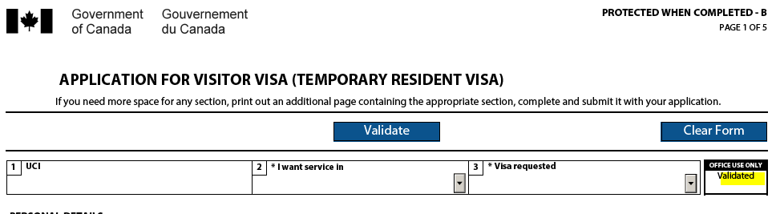

Should update personal details as per passport.

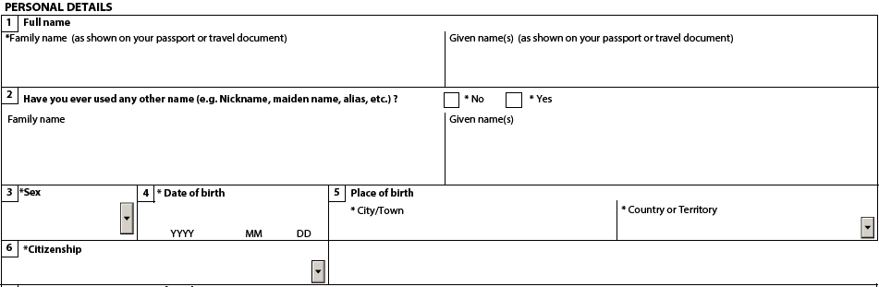

* Current country or Territory of residence – If dependent deputed to any other countries, they should update deputed country details with start date and end date of visa or RP or VR or Petition details.
* If dependent applying and residing in India, they should select status as Citizen.



* Marital status and details of spouse should be checked with marriage certificate.



* If someone divorced, they have to update those details in the below field.



* Should update Native Language or Mother tongue and should update Are you able to communicate in English and/Or French.
* Also, if holding any English proficiency certificate, they must select yes for below question and provide us the proof of the same.



* Passport details should be cross verified with passport copy.



* If someone selected yes for National Identity document, they should be update the details and provide the proof of the same. Passport details should not be mentioned as National Identity document.



* Current mailing address should be always blank, address details should be updated in Residential address field only.



* Should update Telephone no alone in VR application form, Alternate telephone number, Fax no and Email address should be updated by our attorneys. If associate updated their details, you can ask them to keep it as blank.

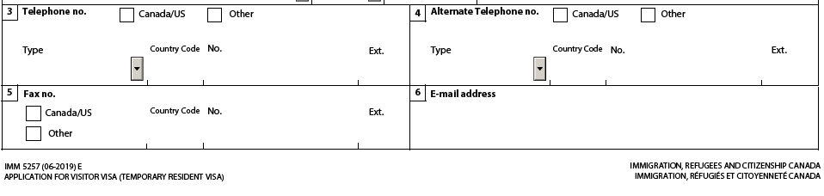

* The purpose of my visit should be Others, in the B) other section should be updated as Accompany spouse, if child VR form should be updated as Accompanying parents. Should be updated Indicate how long you plan to stay, it should be match with primary applicant details of expected work in Canada.

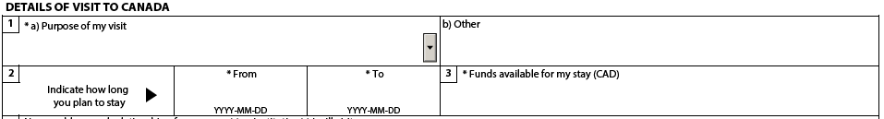

* Should be update TCS associate name and relationship with dependent, in child VR form should be update both father and mother details.

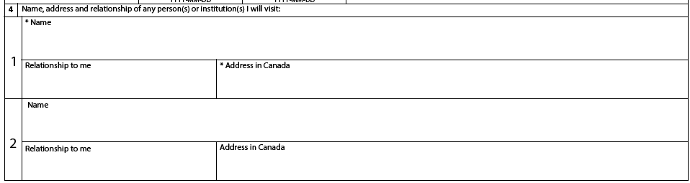

* Spouse Highest Degree details should be updated.



* Employment history should be provided for last 10 years (All the activities – employment, unemployment, education) of all the activities should be captured without any gaps. Onsite and offshore details should be separately provided and if dependent serves different roles, separately update those duration.
* In the child VR application form – should be provided for last 10 years, if child age is less than 10 years, should be given history for till birth.



* Most recent 3 entries should be updated in VR application form. Remaining of details should be updated in additional employment sheet.



* In the Background information field should be updated by depedents, if earlier visa refused means, need to update those details and share us the proof of refusal letter. If someone already travelled to Canada or applied, they should update those details in 2 D section.



* Should not be sign and do not validate the form, please select the concern of contacting in future by IRCC should be answered.



**IMM 1294 (Study Permit application form) current version 10 2019 (APPLICABLE FOR KIDS AGE MORE THAN 5 YEARS):**

* Should not be validated or sign, we require editable form.

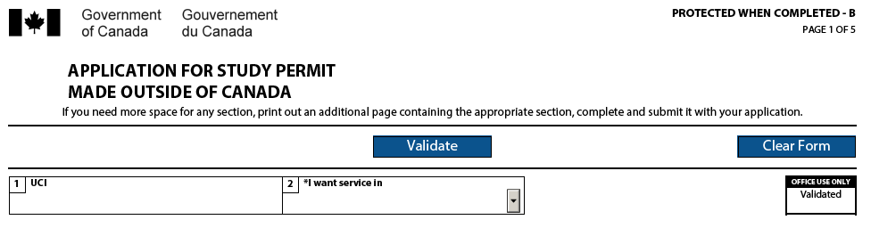

Should update personal details as per passport.



* Current country or Territory of residence – If dependent deputed to any other countries, they should update deputed country details with start date and end date of visa or RP or VR or Petition details.
* If dependent applying and residing in India, they should select status as Citizen.



* Marital status should be Single.



* Should update Native Language or Mother tongue and should update Are you able to communicate in English and/Or French.
* Also, if holding any English proficiency certificate, they must select yes for below question and provide us the proof of the same.



* Passport details should be cross verified with passport copy.



* If someone selected yes for National Identity document, they should be update the details and provide the proof of the same. Passport details should not be mentioned as National Identity document.



* Current mailing address should be always blank, address details should be updated in Residential address field only.



* Should update Telephone no alone in SP application form, Alternate telephone number, Fax no and Email address should be updated by our attorneys. If associate updated their details, you can ask them to keep it as blank.

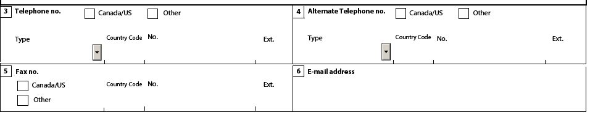

* Should be mentioned name of school as To be decided or NA at this time. Must update duration of expected study.

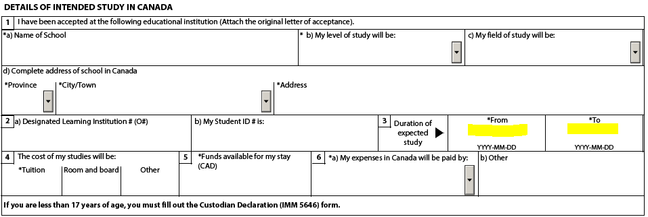

* In the employment section, child all details should be provided for last 10 years, if age is less than 10 years should be provided till birth without any gaps.

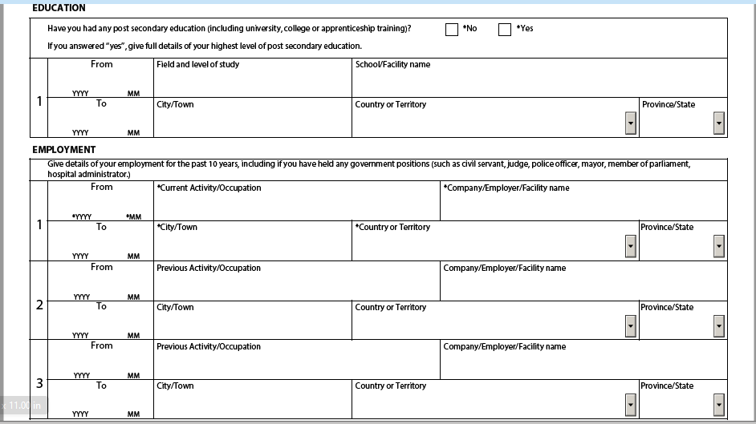

* In the Background information field should be updated, if earlier visa refused means, need to update those details and share us the proof of refusal letter. If someone already travelled to Canada or applied, they should update those details in 2 D section.



* Should not be sign and do not validate the form, please select the concern of contacting in future by IRCC should be answered.



**Marriage certificate:**

* Should be in English version and legible copy required.

**Birth certificate is for kids:**

* Should be in English version and legible copy required.

******